Purpose

The purpose of this procedure is to explain how to use the Review Camp Analyzer to parse through online consumer star-rating reviews.

Scope

The scope of this procedure is limited to high-level analysis of online star-rating reviews, including trends by year, trends by vendor, and keyword hits.

Process Inputs & Outputs

Inputs:  Review Camp star-ratings | Outputs:  Trends by Year  Trends by Vendor  Keyword hits  Keyword star distributions

Definitions

Review Camp: An online product review aggregator.
Star Rating: A metric for consumers to judge product performance on, 1 star being the worst and 5 stars
being the best
Keyword: A frequently used word, depending on the type of product.

Responsibility

Quality Dept.: To identify and analyze prevalence of negative keywords by consumers, indicating product
quality issues.
NPD Dept.: To identify and analyze prevalence of negative keywords by consumers to help drive better
quality into new products, and to judge public perception of features of recently launched product.

Process Flowchart

No flowchart has been created for this Quality System Procedure.

Procedure

- Open a web browser and log in to your Review Camp account
- Select a product you would like to investigate
- Download all the spreadsheets for that product from each vendor, and merge into a single spreadsheet. Delete the header data (the first two rows). Save this locally on your computer, in a readily accessible location.
- Open the Review Camp Analyzer
- Click the “Search” button at the top of the window (Photo 1)
- Navigate to your file in the pop up and select it. Click “Open”.
- The program will parse through the spreadsheet and prompt you with the selection of the product type if successful. If the file was unable to be opened, or in an incorrect format, the console on screen will display an error message. (Photo 2)
- Enter in the product SKU in the pop-up window (Photo 3)
- The data will populate the table at the top of the window with star distributions, counts of reviews by vendor, and counts of reviews by year.
- Bar Charts
  - Clicking on the “Total Star Ratings” will show a bar chart of all the reviews in the system
  - Clicking on the “Star Ratings by Year” will show a bar chart of star ratings grouped by year, on a percentage by year basis, i.e., all the star rating percentages from each year will sum to 100%.
  - Clicking on the “Star Ratings by Seller” will show a bar chart of star ratings grouped by online seller, on a percentage by year basis, i.e., all the star rating percentages from each online seller will sum to 100%.
  - Clicking on the “Keyword Pareto” will display a bar chart of the number of reviews that contain major keywords for the selected product type.
  - Clicking on “Custom Keyword Search” will display a pop-up window where you can enter up to 5 keywords that are specific to this set of reviews. Once submitted, the program will display a distribution of star ratings, clustered by keyword. This is useful for judging positive and negative perception of features of product. (Photos 4 and 5)
- Take a screenshot of the screen by clicking on “Screen Capture” at the bottom of the window, or under File -> Screen Capture from the menu bar.
- Add product types to the system by going to Settings -> Add Product Type, and enter the product type into the pop-up window. (Photo 6)
- Add keywords to be used in the Keyword Pareto chart by going to Settings -> Edit Keyword Sets, and enter each keyword into the text box and click “Add”. (Photo 7

Record Management

Document History
REV | DESCRIPTION | DATE | CREATED BY
A | Initial release | 10/25/2019 | S. Waiss

Reference Documents
Document Type | Document Number | Document Title

Appendix

Photo 1: Landing screen and file navigation
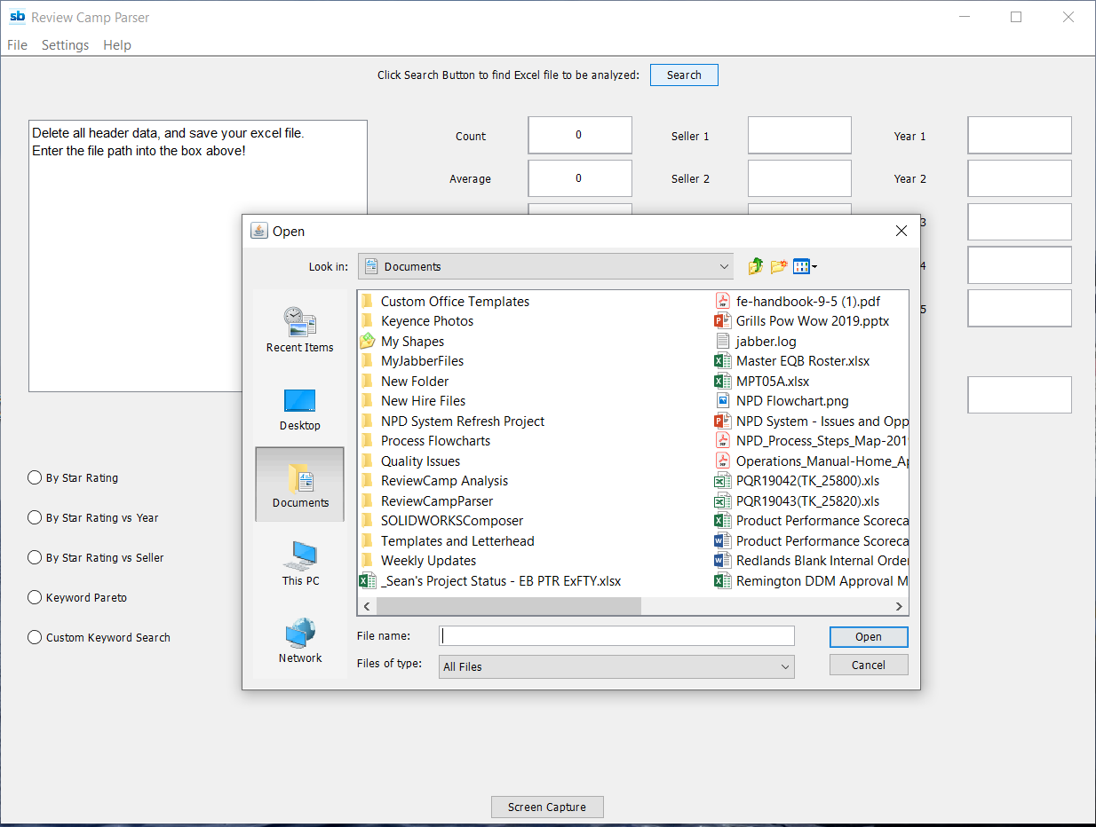
Photo 3: Entering in the product SKU
Photo 2: Successful file reading results
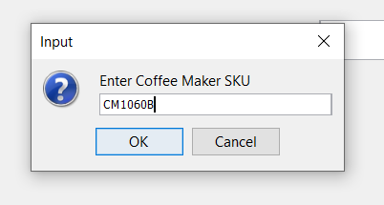
in a window to select the product type
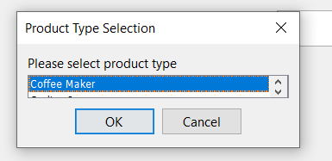

Photo 4: Entering in custom keywords to view star distribution
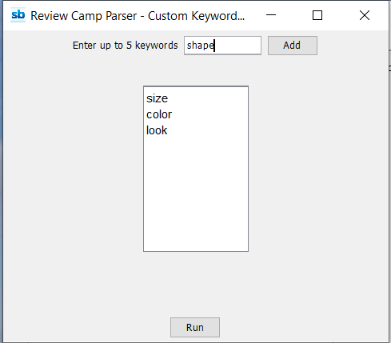

Photo 5: The resulting graph of Star Ratings of Custom Keywords
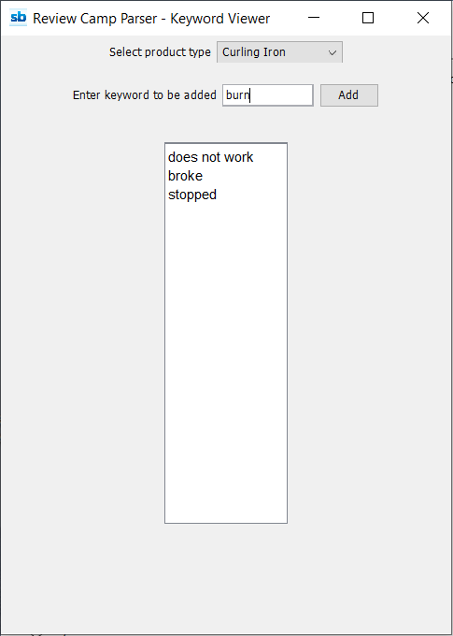
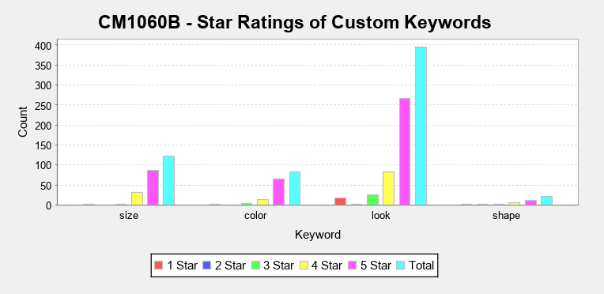
Photo 7: Editing Keyword Sets

Photo 6: The “Add Product Type” interface
